- The end of the temporary increase in stamp duty thresholds triggered a surge in lending and transactions in March as buyers raced to beat the deadline. Though we're likely to see a softer patch for UK housing activity and prices in the short-term, the market looks healthier than it has for some time, with lower mortgage rates and high pay growth easing affordability constraints.
- Mortgage rates should fall further in the short-term in response to the recent drop in swap rates. Markets expect the Monetary Policy Committee to take a more proactive approach to loosening policy, and next week's meeting should give a strong steer as to whether the MPC is sufficiently concerned about demand that it's willing to look past its worries about weak supply.
In a quiet week for data, the Bank of England's Money & Credit release for March took the eye. In September 2022, the previous government temporarily increased the zero-rate threshold for main residences and the first-time buyer threshold for stamp duty, reducing the cost of buying a house. The thresholds returned to normal levels from April 1, so we expected to see surges in lending flows and transactions in March as buyers completed to take advantage of the lower transaction cost.
And so it proved. Net mortgage lending rose to £13bn in March, a figure only bettered in June 2021 when the pandemic-era temporary increase in thresholds expired (Chart 1). Data from HMRC reported 177,000 transactions in March, 88% higher than the monthly average of the previous year. The scale of these increases was a little surprising given the pickup in mortgage approvals at the end of last year had been relatively muted. But overall, the impact of the change in thresholds was in keeping with similar instances in the recent past.
Those past experiences suggest some of the activity will have been brought forward, so Q2 will see some payback. Early data appears to be bearing this out. Mortgage approvals of 64,300 in March were more than 4,000 down on October's peak, implying softer lending flows in the months ahead. This picture extends to prices, with Nationwide reporting a 0.6% month-on-month fall in April after a strong Q1.
Chart 1: Mortgage lending surged in March as buyers raced to beat the stamp duty deadline
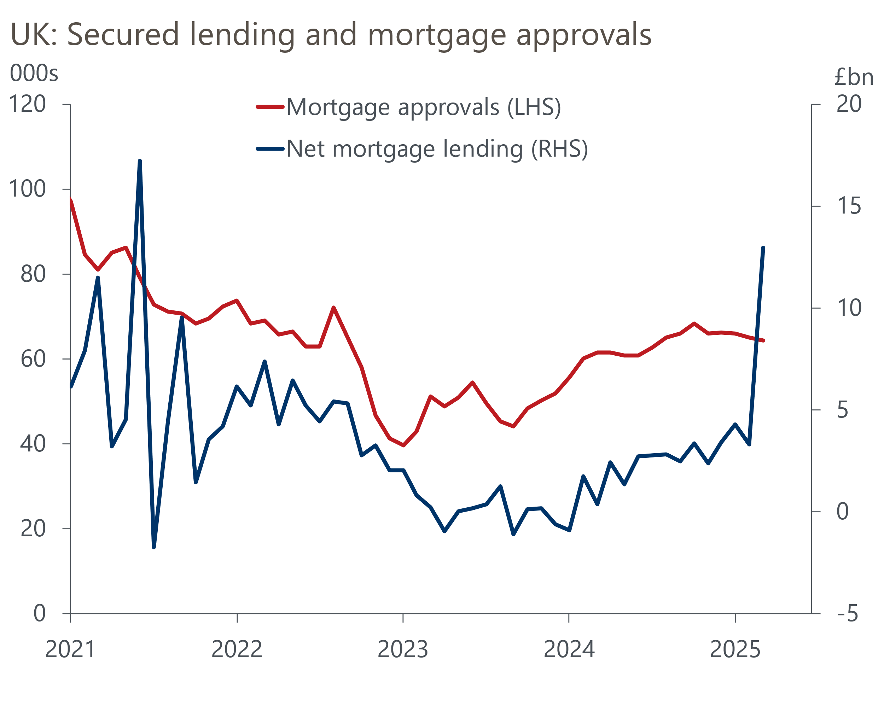
Source: Haver Analytics

Stepping back from the policy-induced volatility, the affordability problems that have plagued the market for the past few years continue to ease. In late-2022, during the short-lived Truss government, our New Home Buyer Affordability Index suggested that house prices were overvalued by 33%. But a combination of falling mortgage rates, strong pay growth, and subdued house prices has left prices just 9% overvalued now.
We expect the valuation gap to recede further through the rest of the year, reflecting resilience in pay growth and further falls in mortgage rates. Two- and five-year swap rates have fallen around 40bps since the start of April, largely reflecting expectations of looser monetary policy in response to recent US tariff announcements. That call will be tested next week, when the Bank of England's Monetary Policy Committee announces its May policy decision and publishes its Monetary Policy Report.
We regard another 25bps rate cut as a near certainty, and markets agree. The more interesting question is what happens next. So far, this rate cutting cycle has seen the MPC cut at alternate meetings. But markets have moved to price a 60% chance of another 25bps cut in June. We think there's a strong argument for loosening policy more quickly in response to the demand shock caused by US tariff announcements. But whether that happens will depend on if the MPC believes the threat to demand outweighs its previous concerns about supply. We'll be reading the minutes closely to see if there are any subtle changes of language that open the way to a more proactive approach to loosening policy.
Separately, the Office for National Statistics has published an update on its project to incorporate groceries scanner data into the inflation statistics. This move should improve the accuracy of the data by improving product and geographic coverage, while also incorporating the impact of multibuy and loyalty scheme discounts by recording transaction prices rather than advertised prices.
In its analysis, the ONS presented estimates of how CPI inflation would have looked in recent years against estimates based on methodological changes introduced in February. This showed inflation would have been slightly lower in recent years had the scanner data been used. But February's methodological changes haven't been applied to earlier estimates of CPI; had the data been revised further back it would also have resulted in lower readings. So compared with published data for CPI, the estimates based on scanner data were lower in 52 of 54 months. The average difference was 0.3ppts, while in June 2021 the estimate using scanner data was 0.7ppts lower than the published estimate of 2.5% (Chart 2).
Chart 2: Introducing grocery scanner data will likely mean inflation is lower in future
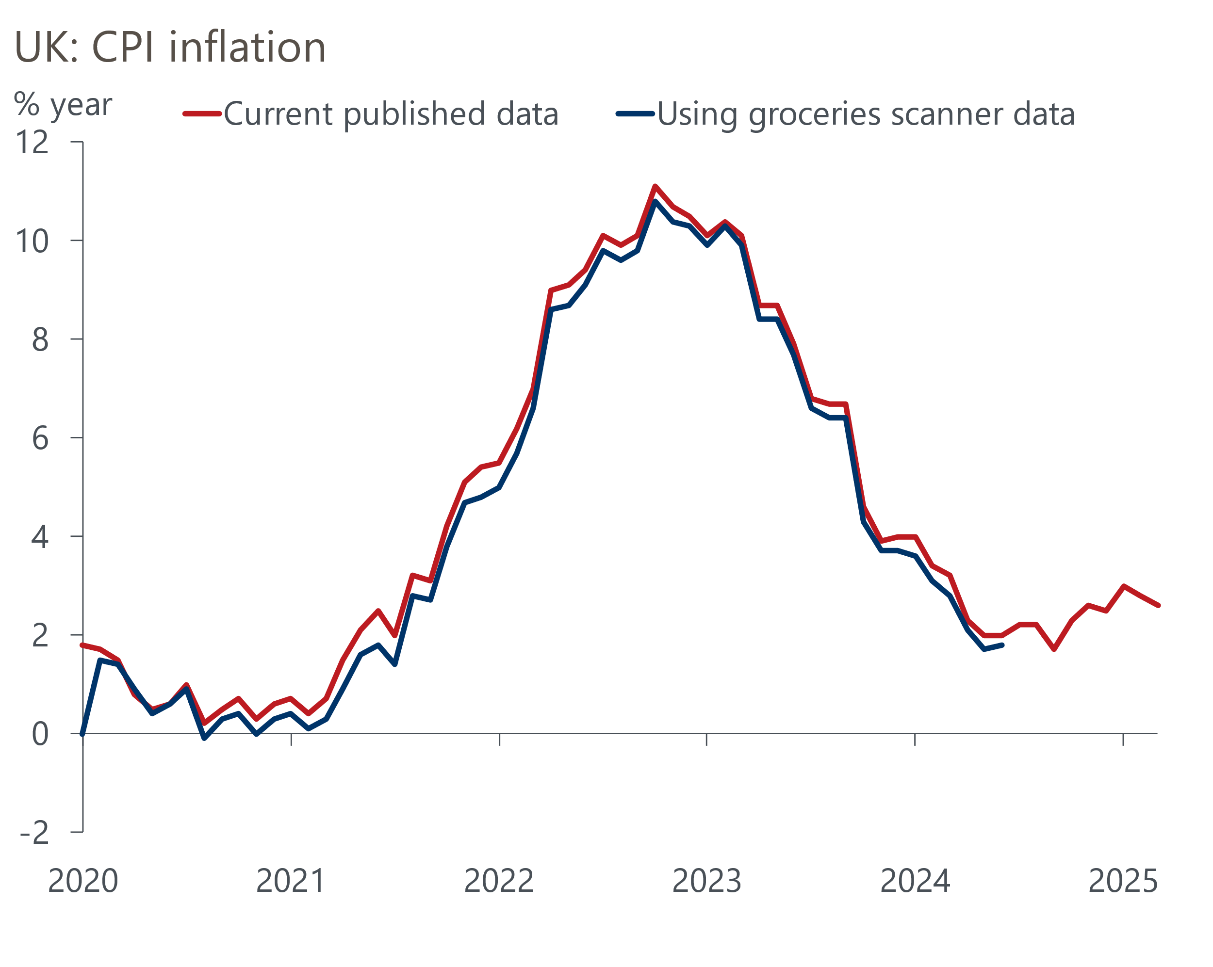
Sources: Haver Analytics, ONS
Pending further quality assurance tests, the ONS plans to introduce the scanner data into its CPI estimates from March 2026 but has said that it will not revise its historical estimates. So if the recent relationship holds, it implies a modest step down in inflation once the new methodology is adopted and slightly softer readings thereafter. But we doubt it will make much difference to the outlook for monetary policy.

The week ahead
Next week will be dominated by May's Monetary Policy Committee meeting. We think a 25bps rate cut is virtually certain and expect at least one vote for a 50bps cut. But the real interest will be around any signals about where policy goes from here in light of recent US tariff announcements. We will be looking for any changes to the MPC's language, with a particular focus on whether it still plans a "gradual and careful" approach to loosening policy. Whether its new inflation forecast delivers an implicit endorsement of the recent fall in market interest rate expectations will also be important.
Next week's only data releases are the remaining S&P Global surveys for April. The flash survey showed a sharp drop in activity, which we think is linked to concerns around US tariff announcements. The flash survey ran until April 22 and there were no major tariff announcements after that date, so there's no reason to think the final outturns will be far from the flash results. Still, this week's manufacturing outturn was a fair bit stronger than the flash reading.
Table 1: Week ahead calendar
Date | Events | Period | Measure | Unit | Previous | Forecast
May 6 | S&P Global services | Apr | PMI | % bal | 48.2 | 48.2
May 6 | S&P Global composite | Apr | PMI | % bal | 48.9 | 48.9
May 7 | S&P Global construction | Apr | PMI | % bal | 46.4 | 45.0
May 8 | BoE Bank Rate decision | May | Bank Rate | % | 4.50 | 4.25
Source: Oxford Economics

Key forecasts
Table 2: UK forecast overview
(Annual percentage changes unless specified)
 | 2022 | 2023 | 2024 | 2025 | 2026 | 2027
GDP | 4.8 | 0.4 | 1.1 | 1.0 | 0.9 | 1.3
Private consumption | 7.3 | 0.5 | 0.6 | 1.2 | 1.1 | 1.2
Fixed investment | 5.1 | 0.3 | 1.5 | 1.0 | 1.0 | 1.6
Government consumption | 0.6 | 1.6 | 3.0 | 2.3 | 1.2 | 1.5
Exports of goods and services | 12.6 | -0.4 | -1.2 | 0.6 | -1.2 | 1.2
Imports of goods and services | 13.0 | -1.2 | 2.7 | 0.8 | -0.4 | 1.1
Industrial Production | -6.4 | -0.8 | -1.2 | -0.2 | -0.3 | 0.7
Consumer prices | 9.1 | 7.3 | 2.5 | 3.0 | 2.4 | 2.3
Unemployment rate (%) | 3.8 | 4.1 | 4.3 | 4.6 | 4.9 | 4.8
Current a/c balance (% of GDP) | -2.2 | -3.5 | -2.7 | -2.6 | -2.8 | -2.6
Government balance (% of GDP) | 4.3 | 5.2 | 5.0 | 3.5 | 3.3 | 2.7
Central bank policy rate (%, EOP) | 3.50 | 5.25 | 4.75 | 3.75 | 3.00 | 2.50
10yr govt. bond yield (%, EOP) | 3.67 | 3.54 | 4.57 | 4.54 | 3.95 | 3.44
Exchange rate (US$ per £, EOP) | 1.20 | 1.27 | 1.25 | 1.29 | 1.29 | 1.29
Exchange rate (euro per £, EOP) | 1.13 | 1.15 | 1.21 | 1.17 | 1.17 | 1.17
Source: Oxford Economics
Table 3: Quarterly forecasts for the UK
 | 2025 |  |  |  | 2026
 | Q1 | Q2 | Q3 | Q4 | Q1 | Q2 | Q3 | Q4
GDP (% year) | 1.1 | 0.9 | 1.0 | 1.1 | 0.7 | 0.8 | 0.9 | 1.0
CPI inflation (% year) | 2.8 | 3.1 | 3.3 | 3.0 | 2.8 | 2.3 | 2.3 | 2.4
Bank Rate (%, EOP) | 4.50 | 4.25 | 4.00 | 3.75 | 3.50 | 3.25 | 3.25 | 3.00
10yr gilt yield (%, EOP) | 4.70 | 4.70 | 4.63 | 4.54 | 4.40 | 4.25 | 4.09 | 3.95
US$ per £ (EOP) | 1.29 | 1.29 | 1.29 | 1.29 | 1.29 | 1.29 | 1.29 | 1.29
Euro per £ (EOP) | 1.20 | 1.17 | 1.17 | 1.17 | 1.17 | 1.17 | 1.17 | 1.17
Source: Oxford Economics

Latest Country Economic Forecast:
April 16, 2025

Recent publications

Data Insights
Stamp duty changes dominate mortgage data
Difficult outlook for the manufacturing sector
Retail's strong start to 2025 may not last
April's flash PMIs plunged amid elevated trade uncertainty
Tariffs pose a big challenge to the fiscal arithmetic

Research Briefings
MPC Preview – tariffs could prompt a less cautious approach
How will central banks react to the trade war?
Higher tariffs damage growth prospects
Trump tariffs will cut UK growth as global demand weakens
Stopgap Spring Statement leaves problems unresolved

Contacts

Oxford Economics' UK team
- Andrew Goodwin - Chief UK Economist - agoodwin@oxfordeconomics.com
- Edward Allenby - UK Economist - eallenby@oxfordeconomics.com

